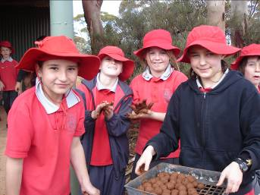
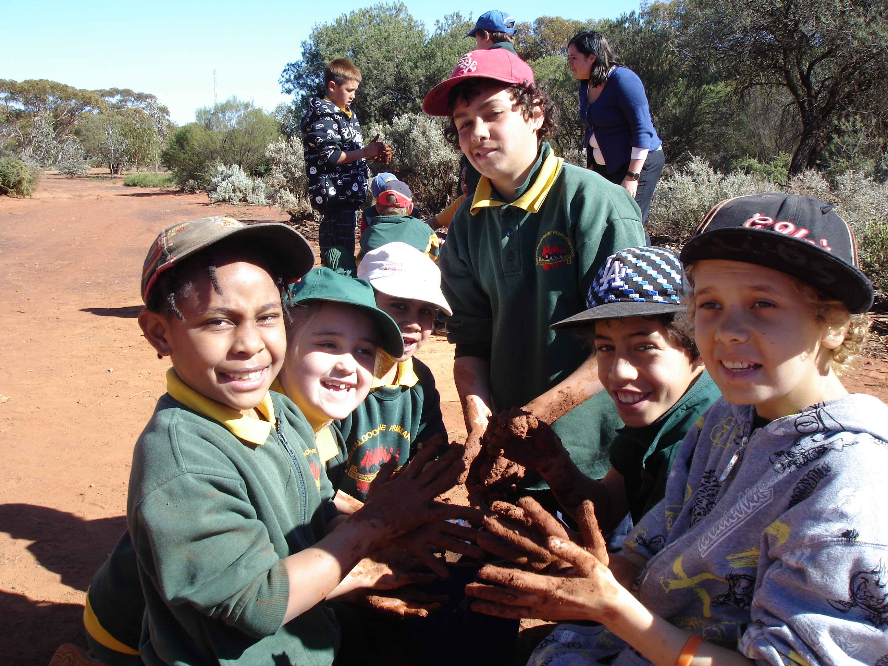
MAKING SEEDBALLS

What You Will Need

- Seeds
Get from KBULG (available to Junior Landcare classes free of charge). I recommend kids wear a face mask when first mixing seed with compost.

- Compost
Collect from beneath the sorts of trees/shrubs you plan to grow. I collected mine from a bushland type area. Look for a tree/shrub with lots of built up mulch underneath it. You are looking for stuff that looks like it has fine, white string through it. The compost needs to be sieved to remove stalks and leaves, then dried in a shaded place.

Note: “Gods Gift” commercially available compost has tested well as a replacement.

- Clay
Collect from a site free of weed seed. The clay MUST be dried and ground finely to ensure a lump free mixture. Two bricks can serve as an effective grinder. Or use a sieve you can get for sifting plant seed raising mixes. I collected mine from Council work sites along Gribble Creek.
The finest clay source is by streams that flood and leave pools of still water to evaporate. The mud at the bottom often shrinks as it dries, and cracks into large pieces. At the very end of evaporation, delicate mud curls like broken pottery may form on the drying surface. Gather them when they are dry. Brush off coarse sand and powder the pieces by grinding between blocks, or stones. The clay needs to be dry and loose. Sift it through a screen to remove large chunks. If there is no local source of clay nearby, you can order terracotta clay from ceramic supply companies.

- Water

Extra Essential Stuff

- Big container/tub - for kids to mix dry mixture in.
Or use several smaller ones – but make sure the ratios seed, compost & clay don’t change.

- Buckets – to divide mixture into once seed, compost, clay have been thoroughly mixed, then last add small amounts of water – therefore creating several work stations for kids to work around in small groups. Working from one main point doesn’t appear to work.
- More Buckets/Hose – to wash kids hands etc. Rinse them before letting them go anywhere; otherwise you will end up with really annoyed cleaners!

- Trays – the ones used in schools for lab work etc are great. For putting the made seed balls in to dry.

Seed ball Recipe

TEACHER HINTS

- A one-litre measure (e.g. an empty milk carton) is recommended. This will make a heap of seedballs. More than enough for one class! In fact, feel free to use a smaller measure.

- Once mixture is wet, it must be turned into balls and dried. It can’t sit a day.

- This is NOT an inside activity! Preferably do outside on grass, or somewhere that can be hosed down. Very messy & muddy!

- With young kids, find some adults or older kids to be a ‘leader’ for each group.

RECIPE

Mixing Proportions By Volume *
1 Part: Dry Mixed Seeds with all kinds of desired plants.
3 Parts: Dry Compost with fungi and soil microbes, (plant compost, not animal manure).
5 Parts: Dry Red or Brown Clay, finely powdered and sifted, not gray or white clay, if possible.
* Mix ingredients DRY, turning and sifting to coat seeds with soil, then clay, then add: *
1 to 2 Parts: Water added a little at a time until the clay mix is easily workable. Don’t over wet!

- After thoroughly stirring the seeds in a large flat container, and covering with dry soil humus from compost, dry clay is added and mixed well. NOTE: Use a face mask for this first mixing, as the Mulla mulla seed in the KBULG seed mix can be very dusty.
- In large batches, layer the seed and soil humus combination with clay to insure proper mixing, however, make small volumes to begin with.
- Water is then gradually added until a firm suitable consistency is reached for rolling the seeded clay into half inch diameter balls. Size of a small marble – No big, huge ones – these won’t work & are a waste.
- Wet clay is pinched off the main mass and rolled between the palms of the hands until smooth and round.
- A transformation occurs within the balls as they are rolled, and after a few seconds the clay can be felt to set up or organize, as the tiny clay platelets align themselves to each other, and the seeds they enclose. It is important to roll the clay until this polymerization is felt. The balls then dry with structural integrity. (i.e they don’t fall apart when they dry!)
Tell kids: “The seed ball should be the size of a small marble and should feel ‘sound’.”
- Finished seed balls are tossed onto a tarp to harden undisturbed for at least 24 hours. Heater drying may damage seeds.
- When dry, seed balls may be stored in a cool ventilated place for weeks or applied immediately. Do not keep in plastic bags. Big plastic bucket with lid cracked a bit, OK.

RULES TO TELL KIDS:

- Most important – once dirty DO NOT touch anything or anyone.

- Cannot wash or wet hands until finished making the seed balls.

- Listen to and do what your group leader or big kid says.

- No throwing or flicking clay.

- Failure to do the above and everyone stops.

Extra Essential Stuff

Smocks: - so clothes don’t get dirty

Big container/tub – for kids to mix dry mixture in.
Or use several smaller ones – but make sure the ratios seed, compost & clay don’t change.

Premix - Divide dry mix into buckets before any water added

Buckets – to divide dry mixture into, once seed, compost, clay thoroughly mixed – therefore creating several workstations for kids to work around in small groups. Working from one main point doesn’t appear to work. Let them mix water in the bucket in small groups.

More buckets, hose/soap – to wash kids hands etc. Rinse them before letting them go anywhere, otherwise you will end up with really annoyed cleaners!

Worked Well:

(Cindy Loo, Hannans PS, Year 1 class).

- Dry mix already mixed (clay, seed, compost) - let kids add some extra seed & mix.

DO NOT ADD WATER TO THIS.
- 20 children, 4 adults or older children - 4 groups of 5 children (Yr1s) to 1 team leader.
- Each group had 1 bucket and 1 tray.
- Added 1 ice cream container (1 litre) of dry premix to each bucket.
- Then I added water, they mixed, then if necessary more water was added.
  - NO ONE other than Land Care Officer was allowed to add water (or even touch it).
- 1 litre of mix between 5 children took about 40 minutes.
- Team leaders shown the size the seed balls should be, how to roll eg smooth and they supervise younger children.
- A big square container & soap was placed under a tap for children to wash in after making the seedballs and a person to guard and monitor this was present.

Seed balls are a great way to protect the native seeds, before we get enough rain to help germinate the seeds inside. Ingredients; Goldfields Clay, Native seeds, Compost and mulch.

Made with love by…………………………………………….

Type of seed………………………………………………..….



