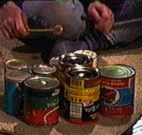
Like all interesting things, the deeper you go into instrument building the more complex it gets. But to get started toward understanding instruments you need to know about four things:

- Vibrations
- Types of Instruments
- How to build louder instruments
- How to get different pitches

Vibrations

On all musical instruments something has to VIBRATE (shake back and forth). The thing vibrating might be a string, drum head, xylophone bar, a tube filled with air, whatever.

Here’s how it works:

First the player has to make something vibrate - pluck or bow a string, hit the drum head or xylophone bar, buzz or blow into a tube filled with air...

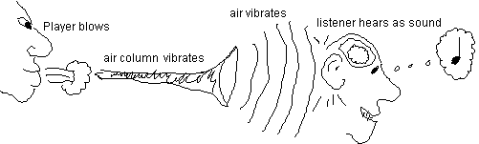
Vibrations are contagious, so the air around the vibrating thing also vibrates, spreading outward in the form of sound waves.
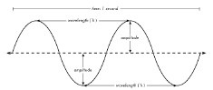

The sound waves hit our ears and we hear the sound. (Actually a pretty complicated process involving the various parts of the ear and the brain.)

Take a look at the example above: The player blows the wind instrument, which causes a column of air inside the instrument to vibrate. This in turn causes the air outside of the instrument to vibrate in the form of sound waves. The sound waves strike the listener’s ear and the brain interprets the vibration as sound.

Instrument Design

As instrument builders we can get all kinds of different sounds from our instruments by thinking about:
- what is vibrating (string, drum head, etc.)
- how it is played (bowed, struck, blown, etc.)
- structure - how the instrument is built, which affects:
- getting it louder (putting it on a box, adding a cone, etc.)
- getting different pitches (longer/shorter, tighter/looser, etc.)

Put all those things together and you have the unique sound (or “timbre”) of a particular musical instrument, whether it be a cello or a soup can hit with a pencil.

Types of instruments

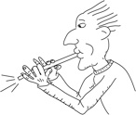
Most of us were taught the traditional Western instrument families: Brass, Percussion, String, and Woodwinds. However when building instruments (or learning about instruments from other cultures) it is better to think about what vibrates:

-Strings
-Air (flutes, horns and reeds and some others)
-Thinly stretched stuff (like drum heads)
-Solid stuff (like xylophone bars, cymbals, etc.)

Once you know what kind of instrument it is (that is, what is vibrating), then you can make some other design changes to help your instrument sound better.

Getting it louder:

One way to play louder on your instrument is just to blow harder, hit harder, etc. But there are some tricks of instrument construction to ensure that you will be heard!

Strings - put it on a box (also called a “resonator”). Wrap your rubber band around a box (cardboard is ok, styrofoam is better), touch your tennis racket guitar to a styrofoam cooler.

Air - With horns (like buzzed cardboard tubes) and reeds (like straw oboes) you can put a cone at the end (note that the cone doesn’t work as well when you have tone holes in your straw). Cones also don’t work with flutes (like blown bottles).

Thinly stretched stuff (like drum heads, balloons, latex gloves, mailing tube covers, etc.) need to have something to stretch them over - like big cardboard tubes.

Solid stuff - there are so many different types of these instruments that it is difficult to know where to start. But here are a few simple strategies:
- -With shakers, use small heavy stuff such as pennies, and put them in a metal container
- -With scrapers, make sure the thing being scraped is rather thin, or hollow (like a coffee can)
- - With pieces of pipe, wood, etc. it is always a struggle to allow them to vibrate. The easiest thing to do is to place them on a big styrofoam box or styrofoam pieces. Another possibility is to use strips of foam rubber.

Getting different pitches

Strings - two different possibilities: tighter-looser (like using the tuning pegs on a guitar) or longer-shorter (like putting your fingers down on the strings).

Air - two different possibilities - longer-shorter (like tone holes on the instrument), and “overblowing” (on certain blown shapes you can get a series of higher pitches by blowing/buzzing harder or faster)

Thinly stretched stuff - mostly tighter-looser (stretch it tighter and the pitch gets higher) but also could be affected by the shape and length of the supporting structure.

Solid stuff - shakers, scrapers, pipers, and pieces of wood - in all these cases size matters. The bigger the thing the lower the pitch.

