00

STYROCELLO

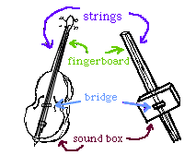
Like many string instruments, Cellos have a fingerboard, a sound box (the curvy body), a bridge (the thin piece of wood that holds the strings in the air) and strings. To build a two-string StyroCello, you will need all those things, too!

YOU WILL NEED:

Fingerboard –
A long, strong cardboard tube - about 3 feet long. It doesn't matter how wide it is, as long as the cardboard is strong - at least 1/4" thick. You can find tubes like this at a local rug store or a fabric store - they are usually quite happy to give them away.

Sound Box –
A styrofoam box or block. The bigger your styrofoam, the louder your styrocello will sound.

Bridge -
A small wooden block - approximately 3" x 3" x 1"

Strings -
Fishing line - the thicker, the better. The best is 60-80 lb test line of the kind used for larger fish. The thinner the fishing line, the softer your styrocello will sound.

Procedure
1. Using a sharp knife (get an adult to help you) cut two small slits on one end of the tube and two more on the other end.
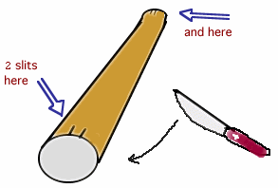
2. Cut a length of fishing line to be quite a bit longer than your tube. Tie a knot in one end of the fishing line.

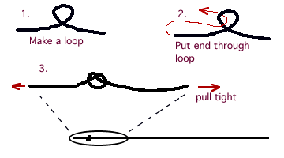
Slide the knot into the slit at the end of the tube with the knot inside the tube. This will anchor one end of the string.
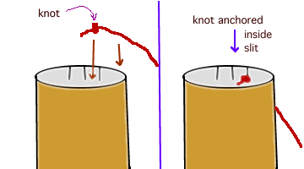

3. Lay the tube on the floor with the styrofoam on top in the middle of the tube [open side down if you have a box]. Then pull the anchored string over the styrofoam to the other end of the tube so that it is semi-tight. Here is where you will tie the second knot and anchor it in the other end of the tube.

Repeat the process with the second string. Try to make it slightly tighter or looser than the other string.

4. Slide the wooden block between the styrofoam and the strings. Then slide the whole styrofoam and bridge assembly down the tube until the strings are nice and tight.
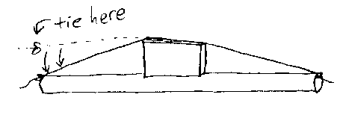

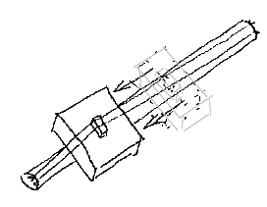

TO PLAY:
Place the box end of the styrocello on the floor and lean the instrument back against your shoulder as you sit in a chair. Pluck the strings just above the bridge. To change pitch you can place your fingers against the strings near your shoulder to create a pizz effect; or slide a pencil up and down the strings as you pluck to get a gliss sound.

You may want to use a violin or cello bow on your styrocello. A bass bow should get an even bigger sound.

