00

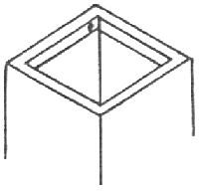
Tea-chest Bass
You need:
- a tea-chest or similar large, strong container
- 3 pieces of square stick about 7½cm long
- a screw
- a drill
- a piece of thick dowel or broomstick 1 meter long
- a double-bass string (a cello string if you are not very tall)
- plastic wood or cement

Step 1:
With the tea-chest open side up, put the screw into place close to one corner, on the inner side of the rim. (The black dot on the diagram shows the correct position.) Use your drill to start it off.

Step 2:
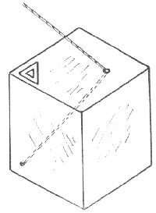
Turn the tea-chest upside down and drill a fairly large hole in the center of the top. Smooth this carefully and coat it with plastic wood or plastic cement to lessen friction.

Step 3:

Tie the bass string firmly to the screw and pass it up through the hole. Glue the three pieces of wood to make a triangle in the corner over the screw.

Step 4:
Saw a notch in the dowel about 15cm from one end. File the other end until it is rounded. Tie the end of the bass string round the dowel above the notch. As it is very thick and stiff you may need to bind it in place with the help of string. Use the notch in the wood to keep it from slipping.

Step 5:
Rest the rounded end of the pole in the triangle of wood. If possible, put one foot up on the box to hold it steady. Move the stick backwards and forwards. As the string is stretched or slackened the note you make when you pluck it will change.

To play:
With patience you can get really skillful at choosing your notes and you can add backing to the music you play. With the zither, the rubber band harp, the xylophone and the slian you can make a real ‘group’. Get a singer and you are away.

