00

Mini Lagerphone

You need:

- 2 sticks of squared wood 30cm long and about 2.5 x 2½cm square
- 16 or more bottle caps
- 16 or more nails or tintacks with good heads, about 2½cm long
- 1 mail a little thicker than the rest
- a hammer
- glasspaper
- a file
- enamel paint of different colors

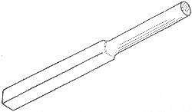

Step 1:

Smooth all the faces of both sticks. File the corners off one end for about 15cm to make a comfortable hand hold.

Step 2:

Paint the top surfaces of the bottle caps in several different colors. With a thick nail punch a hole in each. With the thinner nails, attach them to the different faces of the shaker pole. Do not hammer the nails right in, so that you leave a little free space for the metal caps to rattle. Vary the colors on each face.

Step 3:

You will need to drive the nails in in rotation so that they come to different levels in each face of the wood. Two nails meeting in the middle might split the pole.
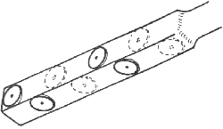

Step 4:

If you have left the nails sticking out far enough the bottle caps will rattle as you shake the sticks, one in each hand.

Shaker poles can be used like maracas in a calypso; or they can be the jingling harness of horses or reindeer; or they can be the sounds of glass hangings swaying in an Eastern garden; or rain falling heavily.

